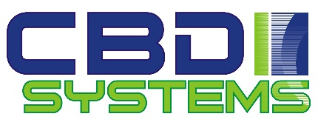
New client registration form Solomons clients
Clients name :

Clients contact phone details :
Clients physical address :

Clients Email address :

Do you have a registered business in the Solomons ? what is business registration number ?

To receive goods into the Solomon’s you will need an account with either TNT or DHL are you able to arrange this ?

Can you provide evidence that you have an existing store that can sell to the public if not please detail how you intend to sell your purchased goods.

Payment for goods, can be obtained by bank Telegraphic transfer, credit card ( visa , mastercard )have you got a credit card in place ? please give confirmation ( we don’t need credit card numbers just a simple response).

CBD systems can acquire any goods from Australia for transport to Honiara we charge a fee of 10% of freight value for this service do you accept these fees? Give your response.
Minimum orders ( minimum order is $500 AUD or SBD2734 ) is this ok for you ? please make comment

Please complete this form scan and email to CBDsystems office admin@cbdsystems.com for new client registration

